- Calcular el Resultado de las siguientes expresiones booleanas, si las variables lógicas toman los valores indicados: X = 1, Y = 0, Z = 1

- ( X + Y ) * X + X * Y

= (1+0) * 1 + 1 * 0

= (1) * 1 + 0

= 0 * 1 + 0

= 0 + 0

= 0

- X *Y + X *Z + Y*Z

= 1 * 0 + 1 * 1 + 0 * 1

= 0 * 0 + 0 * 1 + 0

= 0 + 0 + 1

= 1

- Parte. Realizar la tabla de la verdad y el circuito para las siguientes expresiones booleanas.

- A • B + C = S

A | B | C | A | A • B | A • B + C
0 | 0 | 0 | 1 | 0 | 0
0 | 1 | 0 | 1 | 1 | 1
0 | 0 | 1 | 1 | 0 | 1
0 | 1 | 1 | 1 | 1 | 1
1 | 0 | 0 | 0 | 0 | 0
1 | 0 | 1 | 0 | 0 | 1
1 | 1 | 0 | 0 | 0 | 0
1 | 1 | 1 | 0 | 0 | 1

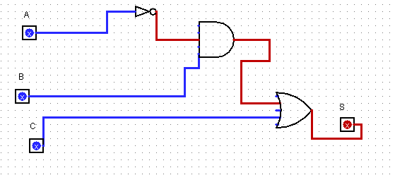

- (A + B) • (A + C) = S

A | B | C | A + B | A + C | (A + B) • (A + C)
0 | 0 | 0 | 0 | 0 | 0
0 | 1 | 0 | 1 | 0 | 0
0 | 0 | 1 | 0 | 1 | 0
0 | 1 | 1 | 1 | 1 | 1
1 | 0 | 0 | 1 | 1 | 1
1 | 0 | 1 | 1 | 1 | 1
1 | 1 | 0 | 1 | 1 | 1
1 | 1 | 1 | 1 | 1 | 1

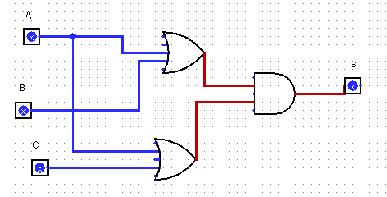

- (A • B) + (A + C) = S

A | B | C | A • B | C | A + C | (A • B) + (A + C)
0 | 0 | 0 | 0 | 1 | 1 | 1
0 | 1 | 0 | 0 | 1 | 1 | 1
0 | 0 | 1 | 0 | 0 | 0 | 0
0 | 1 | 1 | 0 | 0 | 0 | 0
1 | 0 | 0 | 0 | 1 | 1 | 1
1 | 0 | 1 | 0 | 0 | 1 | 1
1 | 1 | 0 | 1 | 1 | 1 | 1
1 | 1 | 1 | 1 | 0 | 1 | 1

